SEM-Based Perovskite Solar Cell Defect Annotation and Detection Using Classical Image Processing and Deep Learning

Abstract
Perovskite solar cells which require attention to microstructure as defects like pinholes, residual PbI2 rich areas, and background morphological variations play a role in charge transport, recombination and device stability. We have developed a Python based annotation, preprocessing and object detection workflow for perovskite thin film Scanning Electron Microscopy (SEM) images in this project. The system puts together an interactive Streamlit annotation interface, YOLO format label generation, OpenCV and Segment Anything Model (SAM) supported auto annotation, patch-based data set preparation, and model testing across YOLOv8, YOLO11, and Faster R-CNN pipelines. PbI-2, 3D pinholes, 3D-2D pinholes, 3D background, and 3D-2D background. We report a division of 4,701 image patches into 3,759 for training, 467 for validation, and 474 for testing. We have put up 6 YOLO training runs in the repo. Out of which YOLO11m did the best with mAP50 at 0.4219 and mAP50-95 at 0.1905. We see that real time object detectors are useful for fast SEM defect localization but at the same time the moderate mAP scores also bring to light that small, low contrast, texture similar defects still present a challenge. We present a reproducible end to end toolchain for lab annotation, model training, evaluation and also a path forward towards more robust microscopy defect analysis.

1. Introduction
Scanning electron microscopy is a key tool in the characterization of thin film photovoltaic materials as it presents grain morphology, pinholes, phase segregation, surface coverage and other microstructural features which are hard to determine from electrical measurements alone. In perovskite solar cells SEM is used by researchers to determine film quality, to identify fabrication issues, and to compare the results of different additives or processing methods. But manual inspection is slow, subjective and hard to scale when researchers have to go over hundreds or thousands of images across many material and processing variables.

The SEM-Annotation project fills in this void by turning manual image inspection into a practical annotation and model training application. We have a Streamlit app (app.py) which is the interface, we have modular handlers for both manual and automatic annotation, we have utility scripts for patch generation and dataset split, classical image processing filters, YOLO and Faster R-CNN training logic, and we also have saved results of experiments. The project is not a single model but a full out solution which takes microscopy images and turns them into labeled data, trains detectors, compares models and feeds predictions back into the annotation loop.

The issue at hand is to identify and determine the location of perovskite defects in SEM images at the same time that we keep the workflow accessible for researchers which may not be deep learning experts. We have taken a practical hybrid approach to this. We use manual annotation which gives us human input and ground truth. OpenCV methods we have used for transparent and parameterized detection of bright PbI2 like particles and dark pinhole like areas. We also have included SAM which provides for promptable or automatic segmentation when that is available. YOLO models we included for fast localization and also for auto labeling once the model is trained. Also we included Faster R-CNN as a two stage base line for comparison.

The project scope includes annotation, dataset organization, preprocessing, training, benchmarking, and visualization. It does not claim a final industrial-grade defect detector. Instead, it gives a strong applied foundation: a working app, generated labels, trained model artifacts, and enough modularity to improve the dataset and models iteratively.

1.1 Objectives [3]
- Build out a user-friendly SEM image annotation interface for defect bounding boxes and polygon like labels.
- Also support auto and semi auto annotation using YOLO inference, OpenCV threshold/morphology methods, and SAM when the checkpoint is available.
- Also prepare out YO which are compatible with YOLO and which include train/validation/test split files and class metadata.
- Also train and compare many object detection models using mAP50, mAP50-95, precision, recall, F1 score, and also training time.

Also document the implementation choices, pros, cons and put forth future improvements in a formal manuscript format.

1.2 Contributions
- A Streamlit app with five functional tabs: Data Explorer & Labeling, Train Model, Auto-Annotation Inference, Multi-Model Benchmark, and Model Comparison.
- A modular source layout that separates UI logic, model management, handlers, filters, datasets, and scripts.
- A patch-based dataset workflow that converts original SEM images into 224 x 224 training samples with adjusted YOLO labels.
- A benchmark-ready training pipeline for YOLO11 and Faster R-CNN, with saved JSON metrics and visual outputs.
- A classical PerovskiteDefectFilter implementation that can detect bright PbI2 particles, dark pinholes, needle-like crystals, and grain-boundary-like artifacts without requiring deep learning.

2. Literature Review
Deep networks do very complex texture learning but at the same time have to be carefully annotated and trained with large sets of examples, also classical filters are very much used for bright/dark feature interpretation.

Study | Method / Domain | Key Finding | Relation to This Project | Observed Gap
Pan et al., 2025 | Deep SEM segmentation for perovskite materials | Identifies lead iodide, perovskite, and defect domains; highlights manual SEM bottleneck. | This project localizes classes with YOLO boxes and adds app-based annotation. | Needs segmentation-grade labels and validation across more morphologies.
Scientific Reports FAPbI3 framework, 2025 | Multi-model SEM defect detection and Streamlit deployment | Combines preprocessing, deep learning, and practical app deployment. | Very similar motivation; this project adds explicit YOLO benchmarking artifacts and OpenCV/SAM assisted annotation. | Current repo needs stronger model-comparison UI linkage and per-class analysis.
Dey et al., 2022 | Mask R-CNN defect detection in SEM images | Shows instance segmentation can improve defect extent estimation. | This project uses Faster R-CNN and YOLO; Mask R-CNN could be a future extension. | Instance masks would improve pinhole shape modeling beyond bounding boxes.
SEM defect ML/DL review, 2021 | Survey of SEM defect classification and detection | Summarizes CNN and deep-learning approaches for semiconductor SEM inspection. | Supports computer vision for SEM defect workflows. | Perovskite-specific datasets remain limited.
Redmon et al., 2015 | YOLO real-time object detection | Frames detection as single-pass regression, enabling fast inference. | Justifies YOLO for interactive auto-labeling. | YOLO can struggle with small, dense defects and localization precision.
Ren et al., 2015 | Faster R-CNN with RPN | Two-stage detector improves proposal quality using shared convolutional features. | Used as a comparison baseline through torchvision Faster R-CNN. | Training and inference cost are higher than YOLO.
Ronneberger et al., 2015 | U-Net biomedical segmentation | Effective segmentation with few biomedical images. | Relevant future path for pixel-level SEM defect masks. | Requires segmentation masks rather than current box labels.
Kirillov et al., 2023 | Segment Anything | Promptable foundation segmentation model trained on very large mask data. | Repository includes SAM handler for auto-annotation. | Default SAM masks need material-specific filtering and class assignment.
Canny, 1986; OpenCV docs | Edge detection | Formalizes low-error, well-localized edge detection. | Canny is available in OpenCV auto-annotation. | Edges alone over-detect grain boundaries in textured SEM images.
Otsu, morphology, CLAHE literature | Classical thresholding and contrast enhancement | Contrast and morphology remain strong for bright/dark blob extraction. | Used in OpenCV handler and PerovskiteDefectFilter. | Sensitive to illumination, scale, and threshold choices.

The gap addressed by this implementation is practical integration. Many papers present a model or algorithm, but a laboratory workflow needs annotation, preprocessing, dataset splitting, training orchestration, metric visualization, and iterative correction. This project connects those steps in one repository.

3. Project Overview and Repository Analysis
The repository we have is organized around a Streamlit entry point and a modular src package. In app.py which is the main entry point we have five app modes put forth via the sidebar. Also in src/model_handler.py we have YOLO model’s which we load, train, we get out of it training validation metrics, we prepare the data sets and do auto-label inference. In the src/handlers we have what we use for user interface and auto annotation. In the src/filters we have what we use for image processing which includes an adaptive kernel engine and also a dedicated PerovskiteDefectFilter. The scripts folder we have standalone utilities for splitting data sets, training all models, creating benchmark PDFs, image validation and running classical filter experiments.[4]

3.1 Technology Stack and Rationale

Technology | Role | Why Used | Benefits | Limitations
Python 3.10 | Main language | Scientific prototyping and ecosystem compatibility. | Broad library support; simple scripts; reproducible. | Dependency conflicts can occur across CUDA/PyTorch versions.
Streamlit | Interactive app UI | Rapid dashboard and annotation workflow without custom frontend. | Simple to run with streamlit run app.py; good for lab demos. | Complex state, drawing tools, and large uploads need more engineering.
Ultralytics YOLO | Object detection | Fast one-stage detector for auto-labeling loops. | Easy training API; stores curves, weights, and metrics. | Small SEM defects can be difficult; metrics are moderate.
Torch / Torchvision | Deep-learning backend and Faster R-CNN | Supports GPU training and two-stage baseline. | Flexible custom dataset; strong pretrained backbones. | Longer training and more code than YOLO API.
OpenCV | Classical image processing | Thresholding, morphology, Canny, CLAHE, contours. | Transparent, parameterized detection for bright/dark features. | Requires tuning per image class and microscope condition.
Pillow / NumPy / Pandas | Image I/O, array math, data tables | Standard scientific Python utilities. | Reliable data conversion and metric manipulation. | Large images can be memory-heavy without batching.
streamlit-drawable-canvas | Manual drawing UI | Rectangles, free drawing, and polygon-like drawing modes. | Enables human-in-loop annotation. | Current code does not yet reload YOLO labels back to canvas objects.
YAML / JSON | Dataset and metric metadata | YOLO config and model metrics are easy to inspect. | Human-readable and script-friendly. | Path consistency must be maintained carefully.

3.2 Dataset Description
The repository contains balanced_dataset with 440 images and 440 label files, plus split files containing 352 train, 44 validation, and 44 test entries. The model-training split used in the current benchmark is dataset_split_224, containing 4701 image patches and 4701 YOLO label files. Its split files contain 3759 training, 467 validation, and 474 testing samples. The patch size is 224 x 224 pixels, chosen to reduce GPU memory use and make training possible on limited VRAM. [5]

Class ID | Class Name | Object Instances in dataset_split_224 labels
0 | PbI2 | 2910
1 | 3D_pinholes | 3995
2 | 3D-2D_pinholes | 3661
3 | 3D_background | 0
4 | 3D-2D_background | 0

Background classes are represented mainly by images with empty labels. The split contains 1811 non-empty label files. Empty-label background patches are useful because they teach YOLO what not to predict, but the ratio must be controlled so that the detector does not become overly conservative.

4. Application Tabs and Functional Benefits
Tab | Main Functions | Benefit | Current Limitation
Data Explorer & Labeling | Browse class folders, track progress, jump to first unlabeled image, draw labels, run SAM/OpenCV annotation, save YOLO labels. | Supports human-in-loop ground truth creation. | Default path is machine-specific; existing labels are not rendered back to canvas.
Train Model | Collect image-label pairs, write YOLO dataset YAML, train selected YOLO model. | Allows small training runs from UI. | Long training can block Streamlit; scripts are safer for full runs.
Auto-Annotation Inference | Use trained YOLO or SAM to auto-label selected class folders. | Accelerates labeling after an initial model exists. | YOLO confidence must be tuned; SAM checkpoint must be separate.
Multi-Model Benchmark | Train queued models with shared settings and save metrics. | Supports reproducible comparison. | App queue currently differs from broader script training queue.
Model Comparison | Load JSON metrics, render table/chart, identify best model. | Turns outputs into decision support. | Live run exposed path mismatch: app searches runs/metrics, while metrics exist in src/runs/metrics.

5. Methodology
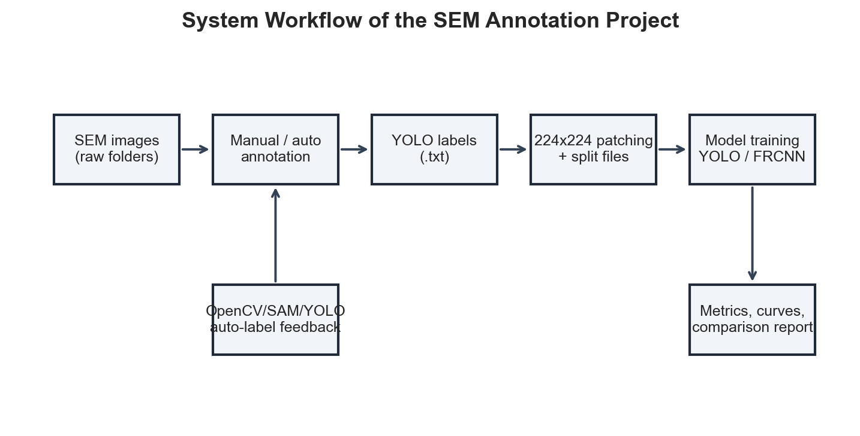
Figure 1. End-to-end workflow implemented by the SEM-Annotation repository.
In the annotation process we begin with a class folder which is chosen in the Data Explorer tab. The application goes through images via utility functions which also check for the presence of corresponding YOLO.txt files and reports progress. As a user you will do the annotation work on a drawable canvas over the image. We see conversion of the drawn rectangles to YOL square center points, width and height. Also free draw or polygon paths are turned into a series of normalized coordinates as we get more points.[6]

The quick auto-annotation which we present includes two modes. OpenCV which we use for the very fast and easy to interpret detection of bright or dark features. SAM which we made available for segment anything out that is when you have the segment anything and the check point file installed. YOLO inference is made available in the Auto Annotation tab which is a trained model that puts out bounding boxes and also produces YOLO label files for images which aren’t already annotated [7].

PbI2 rich particles are what you will see to be bright, in the other hand pinholes will be dark. OpenCV which we use to handle the images has support for thresholding, bright thresholding, top-hat transforms, HSV brightness masks, adaptive thresholding, Canny edge detection, watershed style preprocessing, CLAHE, also we have brightness/contrast adjustment and we can do contour filtering by area [8].

The split out into smaller patches which we create from large scale SEM images. We transform bounding boxes from YOLO’s normalized coordinates to absolute, clip them to the patch borders, and then we put them back into normalized coordinates for the patch space. This we did to preserve labels through the process of patch generation which also allows us to train on memory constrained hardware [9].

YOLO training is done on Ultralytics. ModelHandler.train_model which loads weights, chooses GPU if present, trains the model, loads best.pt, validates it, and puts out JSON reports of mAP50, mAP50-95, precision, recall, F1, epochs, image size, train time, and weight path. For Faster R-CNN we use torchvision with ResNet-50 FPN backbone and a custom dataset that we designed to transform YOLO labels into torchvision target dictionaries [10].

5.1 Pseudocode
Algorithm 1: Patch-based YOLO dataset preparation
Input: SEM image folder, YOLO label folder, patch size P, overlap O.
1. For each image, read the corresponding YOLO label file.
2. Convert each normalized label into absolute corner coordinates.
3. Generate sliding-window patch coordinates with stride P x (1 - O).
4. Clip intersecting boxes to patch boundaries.
5. Discard boxes whose visible ratio is below the threshold.
6. Convert clipped boxes back to normalized YOLO patch coordinates.
7. Save patch image and matching label file.
8. Write data.yaml and train/val/test index files.

Algorithm 2: Hybrid auto-annotation
Input: Image list and output label directory.
1. Select method based on defect class or user configuration.
2. For OpenCV, convert to grayscale and optionally apply CLAHE and brightness/contrast adjustment.
3. Apply threshold, top-hat, color mask, adaptive threshold, Canny, or watershed preprocessing.
4. Extract contours and filter by area.
5. Convert valid contours into YOLO bounding boxes and write label files.
6. For YOLO, run model prediction, extract normalized boxes, and write labels.
7. For SAM, generate masks, filter by predicted IoU, convert mask extents into boxes, and write labels.

6. Module-by-Module Code Analysis
File | Purpose | Benefit | Limitation / Improvement
app.py | Streamlit entry point; defines sidebar navigation and all five app modes. | Integrates labeling, training, auto-annotation, benchmarking, and comparison. | Single-file UI is easy to run but large; future refactor could split tabs.
src/model_handler.py | YOLO loading, training, validation, metrics, dataset preparation, and auto-labeling. | Centralizes model logic. | Metric output path differs from current app comparison path.
src/logger_setup.py | Redirects stdout/stderr to app.log. | Preserves app logs. | File handle management could be context-aware.
src/handlers/canvas_ui.py | Drawable canvas over SEM images with class and drawing controls. | Manual annotation UI. | TODO remains for loading existing YOLO labels.
src/handlers/opencv_handler.py | Parameterized contour-based auto-annotation. | Fast, explainable baseline. | Thresholds require tuning.
src/handlers/sam_handler.py | SAM automatic mask generation and conversion to YOLO boxes. | Segmentation-assisted labeling. | Requires checkpoint; class assignment is defaulted.
src/handlers/utils.py | Directory and image-file listing helpers. | Reusable file scanning. | Only scans direct files.
src/utils/annotation_utils.py | YOLO read/write, coordinate conversion, clipping, and pair collection. | Essential for patching. | Could validate malformed labels more strictly.
src/datasets/frcnn_dataset.py | Torch Dataset that reads YOLO labels and returns Faster R-CNN targets. | Bridges YOLO labels to torchvision. | No dedicated augmentation pipeline.
src/filters/adaptive_kernel.py | Variance, gradient, entropy, adaptive kernel maps, hybrid responses. | Adapts filter scale to local texture. | Heavier than simple thresholds.
src/filters/classical_blend.py | CLAHE, top-hat, black-hat, LoG, DoG, Gabor, Hessian, LBP, DCT, entropy. | Library of interpretable filters. | Some functions are expensive and not fully wired into app.
src/filters/perovskite_defect_filter.py | Mode-aware classical detector with dataclasses and NMS. | Domain-specific no-training baseline. | Needs quantitative validation against ground truth.
scripts/split_dataset.py | Sliding-window patch split with box clipping. | Preserves labels during patching. | Can overwrite output directory.
scripts/split_and_train_pipeline.py | Patching, balancing, splitting, and starting training. | Automates preprocessing. | String-replaces training script path, which is brittle.
scripts/train_all_gpu.py | YOLO11 and Faster R-CNN training orchestration. | Reproducible batch training. | Large monolithic script; hard-coded CUDA assumptions.
scripts/generate_benchmark_report.py / create_benchmark_pdf.py | PDF report generation from JSON metrics. | Automated charts and summaries. | Separate from manuscript report.
scripts/dynamic_kernel_detector.py / demo_pdf_filter.py | Run classical detector experiments and save overlays. | Qualitative visualizations. | Classical detections need threshold tuning.

A line-by-line reading of the implementation shows a design preference for practical reproducibility: simple file-based datasets, YOLO text labels, JSON metrics, and batch scripts. The tradeoff is that several paths are hard-coded to the original Windows machine, and some UI paths diverge from training output paths.

7. Results and Discussion
Model | mAP50 | mAP50-95 | Precision | Recall | F1 | Epochs | ImgSz | Train Time (h)
yolo11m | 0.4219 | 0.1905 | 0.4488 | 0.4820 | 0.4648 | 50 | 224 | 1.14
yolo11s | 0.3957 | 0.1734 | 0.4326 | 0.4582 | 0.4450 | 50 | 224 | 0.62
yolov8s | 0.3779 | 0.1629 | 0.4553 | 0.4249 | 0.4396 | 50 | 224 | 0.46
yolo11l | 0.3526 | 0.1602 | 0.4054 | 0.4315 | 0.4180 | 50 | 224 | 2.95
yolov8m | 0.3528 | 0.1535 | 0.3976 | 0.4300 | 0.4132 | 50 | 224 | 0.65
yolov8l | 0.2374 | 0.0891 | 0.3040 | 0.3083 | 0.3061 | 50 | 224 | 1.17

The strongest recorded model is yolo11m, with mAP50 = 0.4219, mAP50-95 = 0.1905, precision = 0.4488, recall = 0.4820, and F1 = 0.4648. The result suggests that YOLO11m currently gives the best balance of localization quality and training cost in the available experiments.

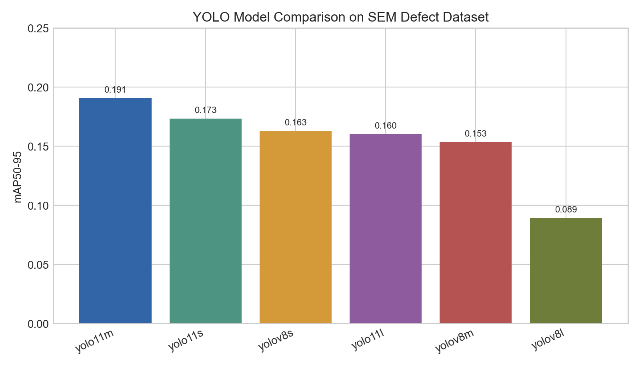
Figure. Model Map5095 Comparison.
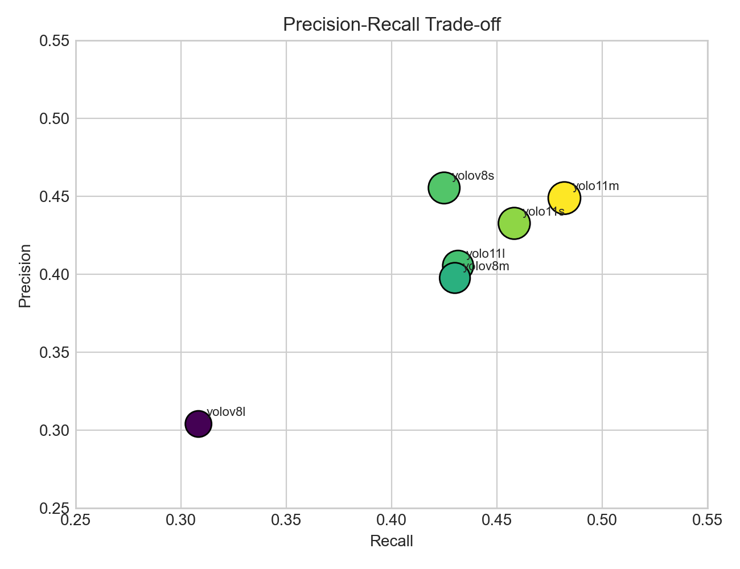
Figure. Precision Recall Scatter.
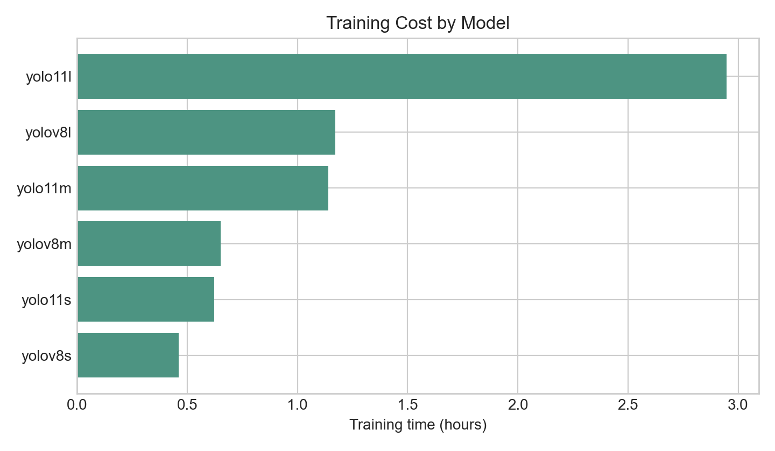
Figure. Training Time.
The quantitative results report moderate to high scores. This is to be expected for small SEM defects which may only take up a few pixels in a 224 x 224 image also what we see is that the grain texture which surrounds the defect often looks like the target class. Also we see that mAP50 is greater than mAP50-95 as the former is more lenient in what it measures it basically pays less attention to box localization. The more strict mAP50-95 instead reports on boundary errors which we see to be a issue when defects are irregular or only partially present after we apply our patch.7.1 Qualitative Visualizations [12]
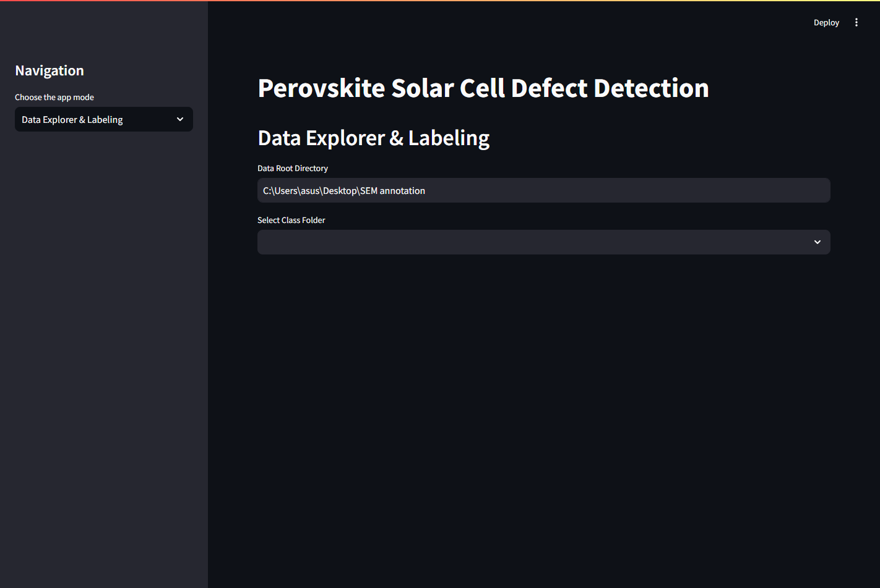
Figure 2. Live Data Explorer & Labeling tab from streamlit run app.py.
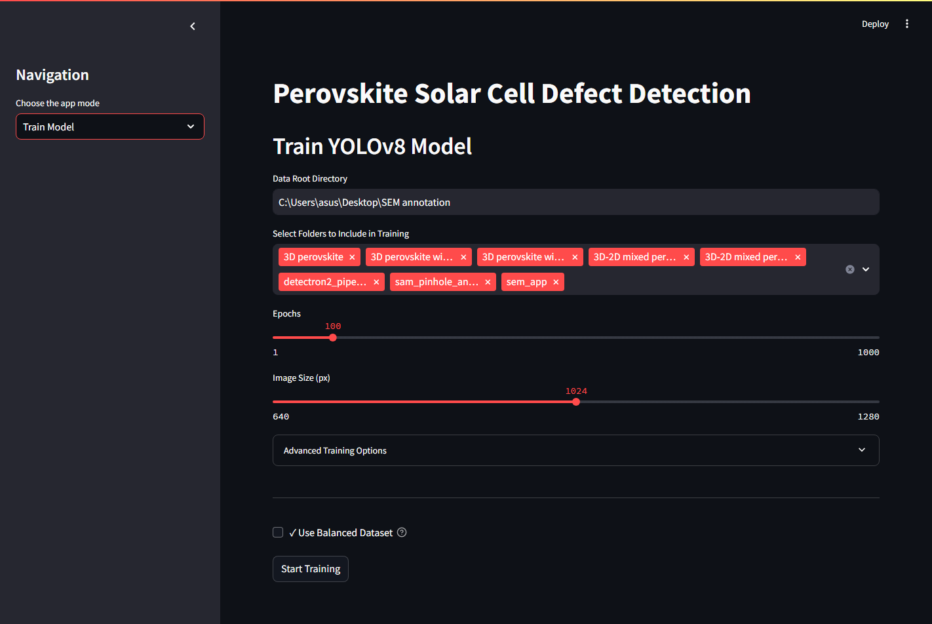
Figure 3. Live Train Model tab.
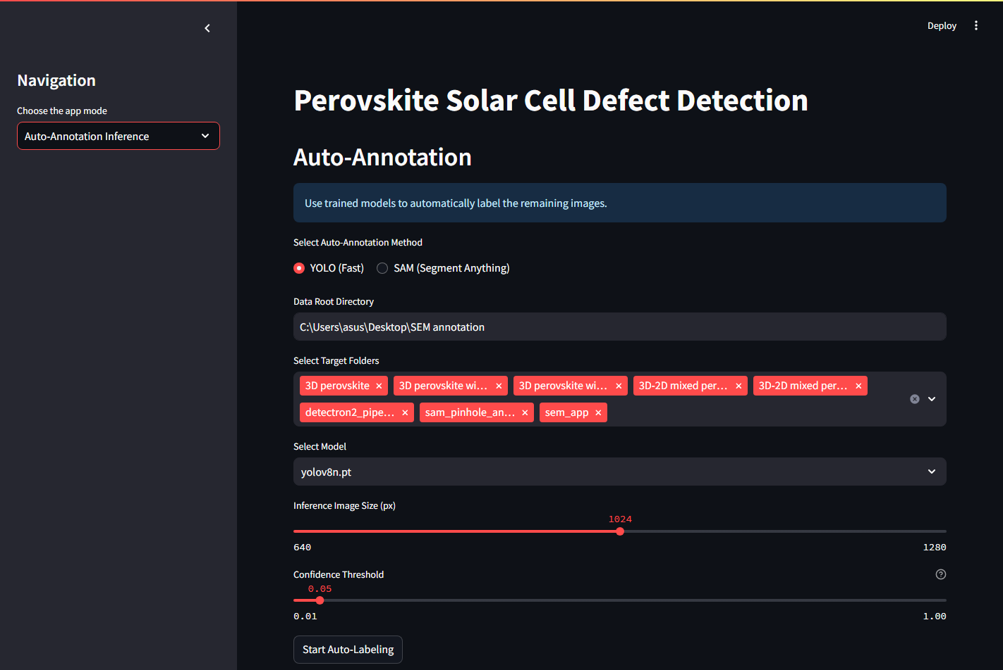
Figure 4. Live Auto-Annotation Inference tab.
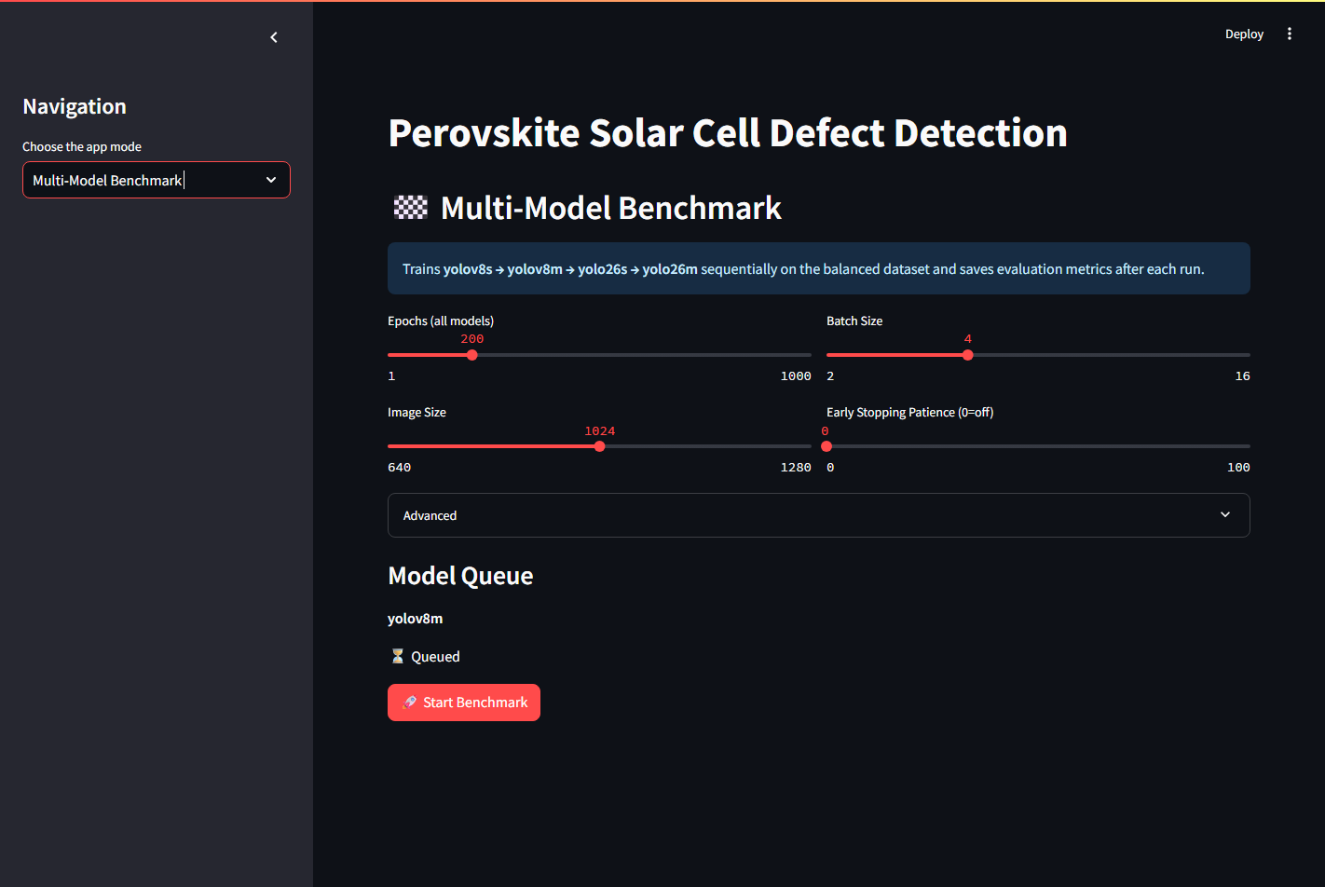
Figure 5. Live Multi-Model Benchmark tab.
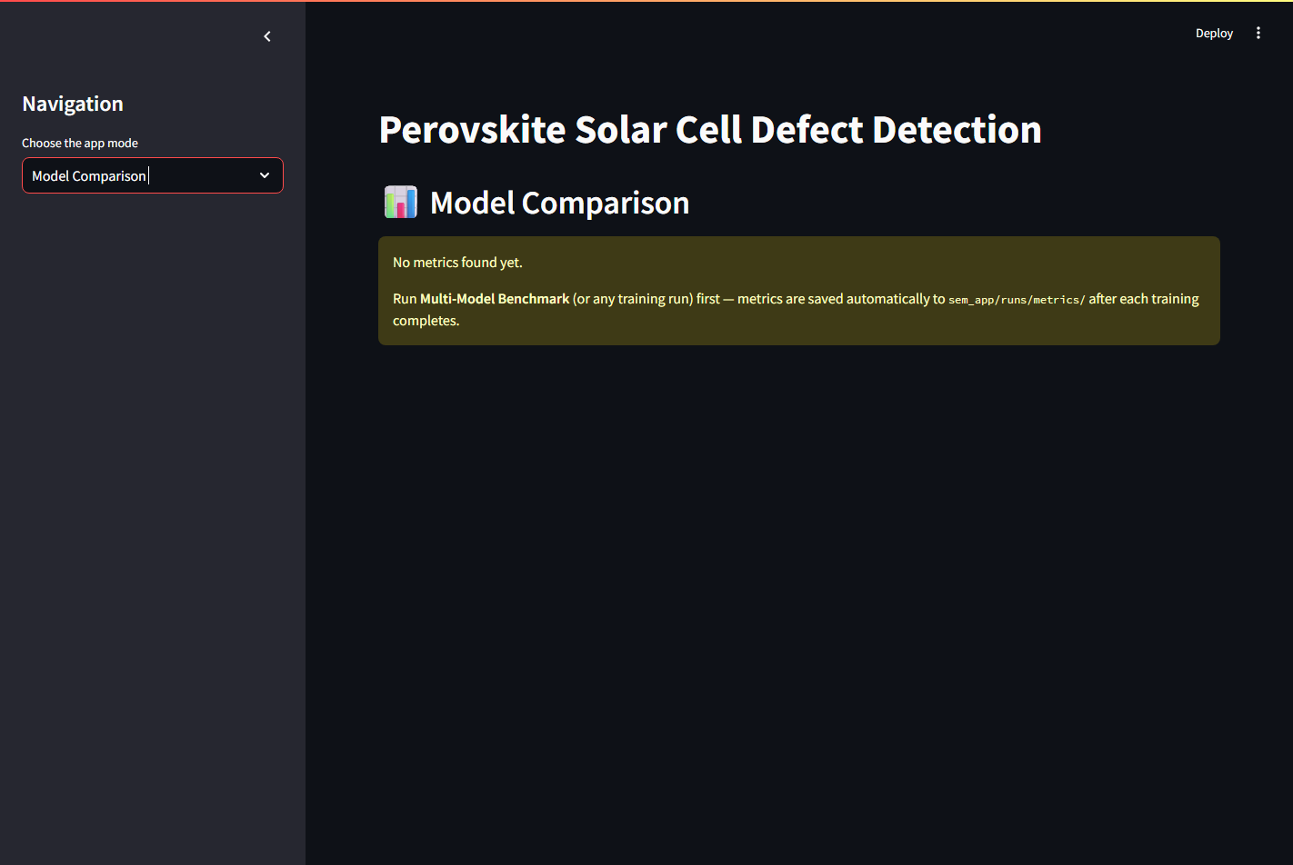
Figure 6. Live Model Comparison tab showing the current metric path mismatch limitation.
-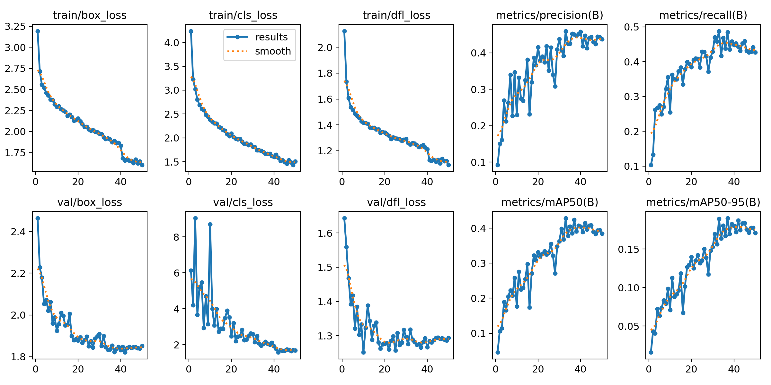
Figure 7. YOLO11m training curves generated by Ultralytics.
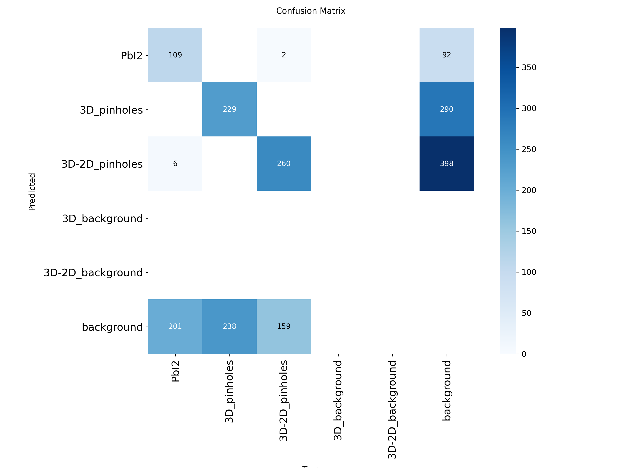
Figure 8. YOLO11m confusion matrix artifact.
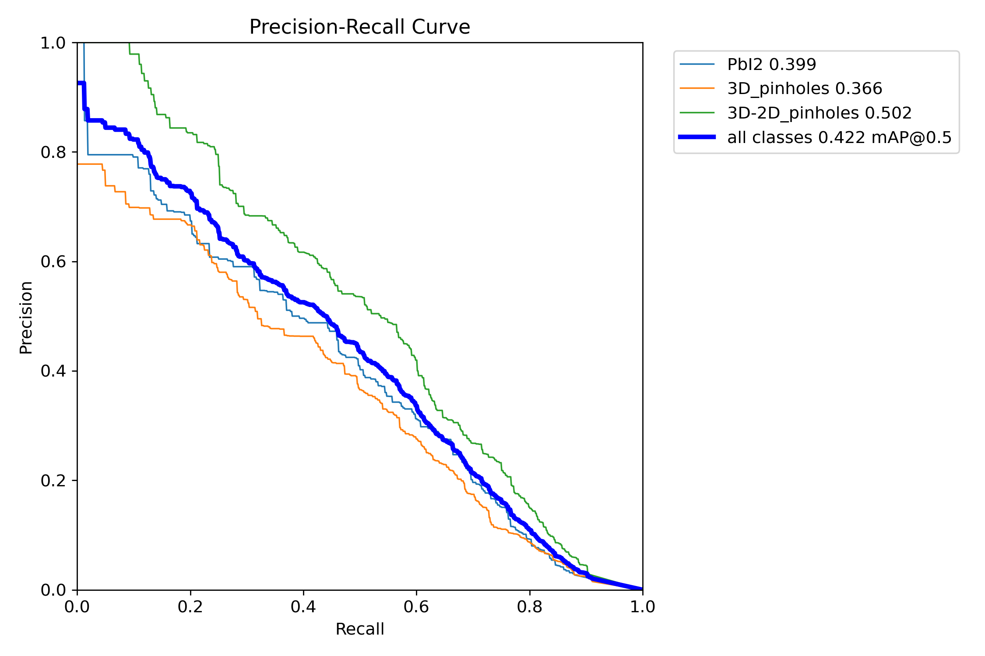
Figure 9. YOLO11m precision-recall curve artifact.
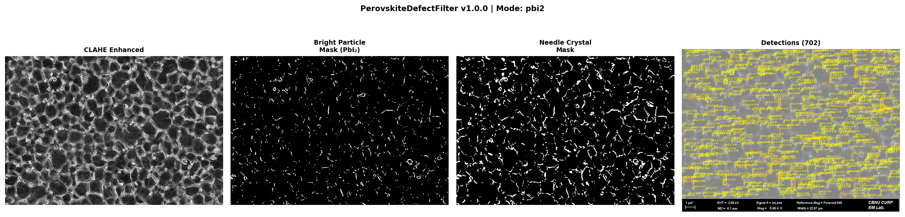
Figure 10. Classical PerovskiteDefectFilter pipeline for a PbI2 sample.
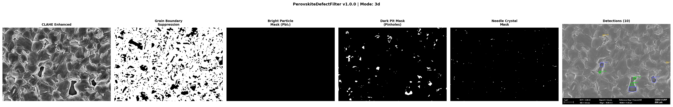
Figure 11. Classical PerovskiteDefectFilter pipeline for a 3D pinhole sample.

7.2 Error Analysis
- Small-object limitation: defects may be tiny relative to the patch, producing weak localization signals.
- Texture ambiguity: grain boundaries, pores, and lighting gradients can mimic pinholes or PbI2 particles.
- Patch context loss: 224 x 224 patches reduce memory load but remove broader film context.
- Path mismatch in app comparison: training metrics are in src/runs/metrics; the live Model Comparison tab searches runs/metrics.
- Manual-label dependency: model quality depends heavily on annotation consistency and coverage.
- Class imbalance: background images are useful, but too many empty labels can bias the detector against predictions.

8. Pros, Cons, and Design Tradeoffs
Decision | Pros | Cons | Interpretation
Streamlit UI | Fast to build, easy to demonstrate, no frontend stack. | State handling and long-running training can be fragile. | Good for academic/lab tool; production may need job queue and API backend.
YOLO labels | Simple text files, widely supported. | Bounding boxes are less precise than masks. | Appropriate first version; segmentation labels can be added later.
224 x 224 patches | Fits low VRAM and increases sample count. | May lose contextual cues and split defects. | Useful for RTX 3050-class hardware; test larger sizes later.
OpenCV auto-labeling | Transparent and fast; no GPU required. | Threshold tuning is image-dependent. | Excellent assistant for first-pass labels, not final ground truth.
SAM | Strong general segmentation prior. | Needs checkpoint and class assignment logic. | Promising for future mask labels.
YOLO11m best result | Best mAP50-95 among available runs. | Still moderate absolute performance. | Needs more data, higher resolution, augmentation, and per-class diagnosis.
Faster R-CNN baseline | Strong two-stage architecture and pretrained backbone. | Longer training and more custom code. | Useful benchmark, especially for small objects.

9. Conclusion and Future Work
This project reports we have put in place a full SEM annotation and defect detection workflow for perovskite solar cell images. We did manual annotation, auto-labeling, applied classical image processing filters, trained with YOLO and also worked on Faster R-CNN infrastructure, did in depth benchmark reporting and saved out the results of experiments. We are using the best available model which is YOLO11m but the mid range mAP50-95 score tells us that we still have large room for improvement in terms of the present dataset and model choices.The repository is valuable because it moves beyond a single algorithm and provides the full loop required in practice: annotate, train, compare, correct, and repeat.

9.1 Future Work
- Fixing of metric path consistency issue which is to be done by getting the app to load from both runs/metrics and src/runs/metrics directories or by standardizing all output under one directory.
- Include in the canvas again the existing YOLO labels which in turn will allow users to edit past annotations visually.
- Add to the Model Comparison tab per class mAP, confusion matrix interpretation, and error examples.
- Evaluate larger patch sizes such as 448 or 640 pixels for additional SEM context.
- Add SEM-specific augmentation: contrast jitter, blur/noise, rotation, scale, and synthetic defect insertion.
- Introduce segmentation models such as U-Net, Mask R-CNN, or YOLO segmentation for irregular pinholes and PbI2 regions.
- Create a formal README submission checklist with dataset permissions, model files, trained weights, and reproducible commands.
- Use external plagiarism and AI-similarity tools before final institutional submission.

10. Submission Compliance Notes
- Document format: This file is generated as a.docx manuscript in single column format with 1 inch margins and Times New Roman 12 pt for the body text.
- For the GitHub repo link: put in the final repo URL on the title page before you submit.
- for Datasets and model files: the local repo includes data folders and YOLO model weights; make sure that dataset sharing is ok before you push to GitHub.
- for README: we include in the repo README.md, PROJECT_STRUCTURE.md, PIPELINE_README.md, QUICK_REFERENCE.md, and also benchmark documentation.
- for Plagiarism/AI reports: this environment is not able to generate an official report. You must generate those reports using the institution’s approved service and submit them separately.

References
[1] J. Guo Pan, L. Wang, and X. Cai, “Automated and Scalable SEM Image Analysis of Perovskite Solar Cell Materials via a Deep Segmentation Framework,” arXiv:2509.26548, 2025. https://arxiv.org/abs/2509.26548
[2] “A multi-model deep learning framework for SEM-based defect detection in FAPbI3 Perovskite thin films,” Scientific Reports, 2025. https://www.nature.com/articles/s41598-025-25848-x
[3] B. Dey et al., “Deep Learning based Defect classification and detection in SEM images: A Mask R-CNN approach,” arXiv:2211.02185, 2022. https://arxiv.org/abs/2211.02185
[4] “A Review on Machine and Deep Learning for Semiconductor Defect Classification in Scanning Electron Microscope Images,” Applied Sciences, vol. 11, no. 20, 9508, 2021. https://www.mdpi.com/2076-3417/11/20/9508
[5] “Investigation of Well-Defined Pinholes in TiO2 Electron Selective Layers Used in Planar Heterojunction Perovskite Solar Cells,” Nanomaterials, 2020. https://www.mdpi.com/2079-4991/10/1/181
[6] J. Redmon, S. Divvala, R. Girshick, and A. Farhadi, “You Only Look Once: Unified, Real-Time Object Detection,” arXiv:1506.02640, 2015. https://arxiv.org/abs/1506.02640
[7] S. Ren, K. He, R. Girshick, and J. Sun, “Faster R-CNN: Towards Real-Time Object Detection with Region Proposal Networks,” arXiv:1506.01497, 2015. https://arxiv.org/abs/1506.01497
[8] O. Ronneberger, P. Fischer, and T. Brox, “U-Net: Convolutional Networks for Biomedical Image Segmentation,” arXiv:1505.04597, 2015. https://arxiv.org/abs/1505.04597
[9] A. Kirillov et al., “Segment Anything,” arXiv:2304.02643, 2023. https://arxiv.org/abs/2304.02643
[10] K. He, X. Zhang, S. Ren, and J. Sun, “Deep Residual Learning for Image Recognition,” CVPR, 2016.
[11] T.-Y. Lin et al., “Feature Pyramid Networks for Object Detection,” CVPR, 2017.
[12] T.-Y. Lin, P. Goyal, R. Girshick, K. He, and P. Dollar, “Focal Loss for Dense Object Detection,” ICCV, 2017.
[13] K. He, G. Gkioxari, P. Dollar, and R. Girshick, “Mask R-CNN,” ICCV, 2017.
[14] J. Canny, “A Computational Approach to Edge Detection,” IEEE TPAMI, vol. 8, no. 6, 1986.
[15] N. Otsu, “A Threshold Selection Method from Gray-Level Histograms,” IEEE Transactions on Systems, Man, and Cybernetics, 1979.
[16] K. Zuiderveld, “Contrast Limited Adaptive Histogram Equalization,” Graphics Gems IV, 1994.
[17] J. Serra, Image Analysis and Mathematical Morphology, Academic Press, 1982.
[18] G. Bradski, “The OpenCV Library,” Dr. Dobb’s Journal of Software Tools, 2000.
[19] OpenCV Documentation, “CLAHE,” 2026. https://docs.opencv.org/4.x/d2/d74/tutorial_js_histogram_equalization.html
[20] OpenCV Documentation, “More Morphology Transformations,” 2026. https://docs.opencv.org/3.4/d3/dbe/tutorial_opening_closing_hats.html
[21] OpenCV Documentation, “Canny Edge Detector,” 2026. https://docs.opencv.org/3.4/da/d5c/tutorial_canny_detector.html
[22] Streamlit Documentation, “Streamlit documentation,” 2026. https://docs.streamlit.io/
[23] Ultralytics, “Mean Average Precision (mAP),” 2026. https://www.ultralytics.com/glossary/mean-average-precision-map
[24] Torchvision Documentation, “fasterrcnn_resnet50_fpn,” 2026. https://docs.pytorch.org/vision/0.26/_modules/torchvision/models/detection/faster_rcnn.html
[25] A. Paszke et al., “PyTorch: An Imperative Style, High-Performance Deep Learning Library,” NeurIPS, 2019.
[26] A. Kojima, K. Teshima, Y. Shirai, and T. Miyasaka, “Organometal Halide Perovskites as Visible-Light Sensitizers for Photovoltaic Cells,” JACS, 2009.
[27] H.-S. Kim et al., “Lead Iodide Perovskite Sensitized All-Solid-State Submicron Thin Film Mesoscopic Solar Cell,” Scientific Reports, 2012.
[28] M. M. Lee et al., “Efficient Hybrid Solar Cells Based on Meso-Superstructured Organometal Halide Perovskites,” Science, 2012.
[29] G. Niu, X. Guo, and L. Wang, “Review of Recent Progress in Chemical Stability of Perovskite Solar Cells,” Journal of Materials Chemistry A, 2015.
[30] M. Saliba et al., “Cesium-containing triple cation perovskite solar cells,” Energy & Environmental Science, 2016.
[31] S. D. Stranks et al., “Electron-Hole Diffusion Lengths Exceeding 1 Micrometer in an Organometal Trihalide Perovskite Absorber,” Science, 2013.
[32] D. W. deQuilettes et al., “Impact of microstructure on local carrier lifetime in perovskite solar cells,” Science, 2015.
[33] W. S. Yang et al., “Iodide management in formamidinium-lead-halide-based perovskite layers for efficient solar cells,” Science, 2017.
[34] H. J. Snaith, “Perovskites: The Emergence of a New Era for Low-Cost, High-Efficiency Solar Cells,” Journal of Physical Chemistry Letters, 2013.
[35] W. Tress, “Perovskite Solar Cells on the Way to Their Radiative Efficiency Limit,” Advanced Energy Materials, 2017.

